
SECS Senior Design Proposal

Project title
Air Cooled micro-CHP unit

Sponsor
OU Clean Energy Research Center
Sponsor Liaison
Jim Leidel  Director of Clean Energy Systems  Oakland University  Clean Energy Research Center / OU INC | 248-648-4805 office  248-765-2027 mobile  www.oakland.edu/energy  www.oakland.edu/cerc

Project Summary
This project involves a micro-CHP, or combined heat and power unit for residential applications. The unique nature is that this will be the first stage of developing a low cost air cooled unit suitable for the residential U.S. market.

A small displacement, single cylinder engine will be provided, converted to run on natural gas (or propane for portable use for this project). A multi-pole, permanent magnet direct current generator will be attached. An exhaust gas heat recovery unit will be fabricated and attached.

A DC power take off system will be designed and connected to the generator output. This will allow us to run and test the CHP unit under load for acoustic and thermal performance.

A rough task list might be as follows:
- remove fuel tank, muffler, carburetor, and pull start
- couple the DC generator to the engine
- install gaseous fuel conversion kit
- install exhaust gas heat exchanger
- fabricate engine base and sound insulated enclosure
- connect to DC power take off system (including battery / inverter setup)
- test the sound and thermal performance under load
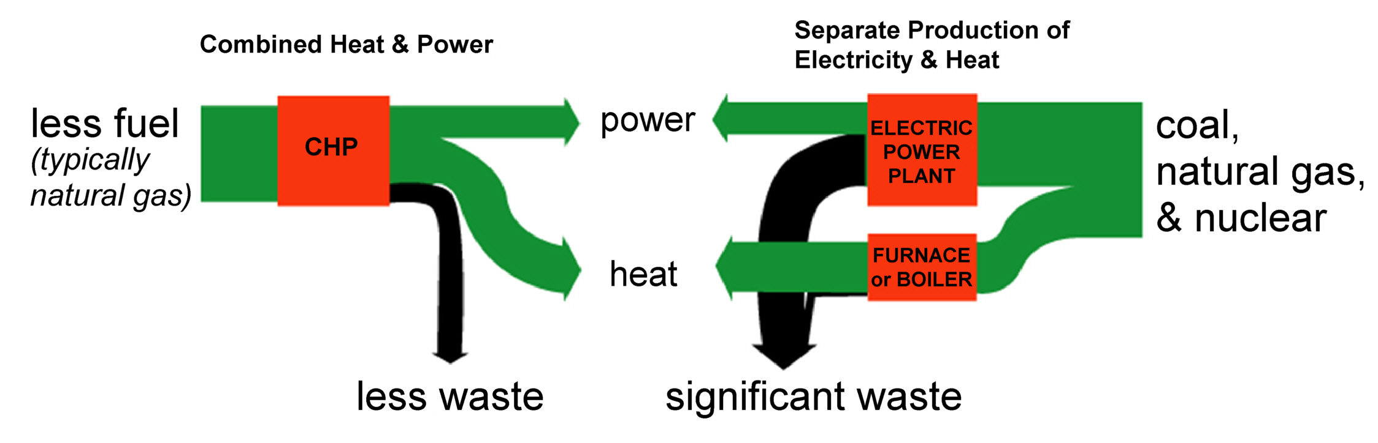
Jim Leidel will assist with the design and provide the electrical DC and AC power take off system as well as assist in its assembly and connection to the microCHP unit.

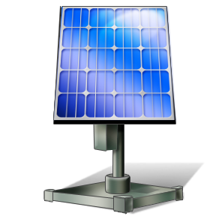
Draft System Schematic
Small
Natural Gas Engine

Permanent Magnet 3PH Generator

3PH
AC to DC Rectifier

Charge Controller
Battery Bank
48VDC
Solar Charge Controller
OutBack
Power
Inverter/ Charger
AC Distribution Panel
AC Loads

