
SECS Senior Design Proposal

Project title
Engineering Center: solar PV test area

Sponsor
OU Clean Energy Research Center
Sponsor Liaison
Jim Leidel  Director of Clean Energy Systems  Oakland University  Clean Energy Research Center / OU INC | 248-648-4805 office  248-765-2027 mobile  www.oakland.edu/energy  www.oakland.edu/cerc

Project Summary
The recently constructed OU Engineering Center building has a roof area intended for solar energy research and testing. The roof has four (4) rack sections, each of 45 foot length total by 5 foot width. Below is a rough layout of the southwest rack for this solar test area.

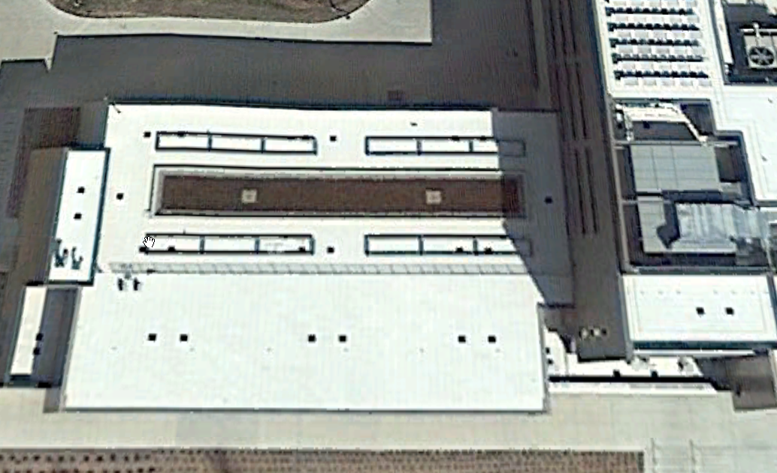

Contractors will install a multi-panel layout of different PV panel types and mountings. The contractor will install the DC and AC wiring, as well as the infrastructure for some data monitoring.

The student project will involve the four scopes of work.
1. fabricate two aluminum racks for two PV panels (each) for a single axis and dual axis tracking mount. The actuators and controls have been purchased, and the student team will design and build the two panel frame, pivots and mount all of this with the actuators to the steel beam structure on the roof.

2. Commission the entire system DC to AC inverter and data collection from each panel. This is Solar Edge system with "DC to DC power optimizers" on each panel to collect the individual power, voltage, and amperage. Another Solar Edge device will feed in ambient temperature and solar radiation.

3. Commission a panel temperature collection controller. Each panel will receive a temperature sensor on it's back, wired to a controller located in a panel on the roof (installed by contractor). The student team will terminate wiring and commission this system to bring in the data. Both of the Solar Edge and temperature data sets must then be merged together with the same timestamp into a database for study and analysis.

4. Time permitting, the last task will be to complete the design and commission two hot water systems associated with the two PV-thermal test sets. The thermal will be dumped locally on the roof to a fin-tube heat exchanger, and the controls will simulate a HW storage tank in a typical application, so that we may study the HW and PV electric performance side by side to the other electric only panels.

5. The last task will involve some analysis of the collected data to make some observations of the temperature vs. efficiencies of various PV types. This will be on-going work for several years following the successful system commissioning.

Solar PV technologies include:
1. crystaline Si PV at fixed 40 deg tilt
2. crystaline Si PV on a single axis tracker
3. crystaline Si PV on a dual axis tracker
4. thin film CdTe (First Solar) PV at fixed 40 deg tilt
5. amourphous Si PV at fixed 40 deg tilt
6. amourphous semi-transparent Si PV at fixed 40 deg tilt
7. CIGS PV at fixed 40 deg tilt
8. polycrystaline Si PV with a thermal hot water system behind, at fixed 40 deg tilt
9. polycrystaline Si PV with a thermal hot water system behind, at fixed 40 deg tilt (glazed)

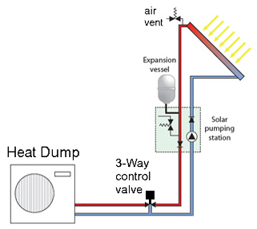

PV-Thermal System, Hot Water Sequence of Operation:
1. When the temperature differential of the solar HW panel and the ambient rises above 10 deg F (adjustable), the pump will run.
2. The 3 Way control valve will modulate to maintain the desired HW return temperature to the solar collectors. 120 deg F (adjustable)
3. The HWS, HWR, BTU heat rate shall be remotely communicated via back to data collection computer (provided by others) in the adjacent lab EC370, approximately 100 feet away.

