EGR 280 – Laboratory Assignment
Method of Joints using MATLAB

We have seen that the forces in each member of a truss can be found by the Method of Joints. Recall that in this method, a free-body diagram of each joint is sketched and the forces acting on the joint are summed in the x- and y-directions. From these free-body diagrams, equations are written balancing the forces applied to the joint.

Solving the system of equations that results from the Method of Joints is a tedious exercise, and can be greatly simplified by the use of matrix mathematics. Furthermore, the coefficients of the matrices involved in the Method of Joints can be easily written down by inspection, leading to a compact and easy-to-apply method for the solution of all statically-determinate truss problems.

To illustrate the method, consider the following example:

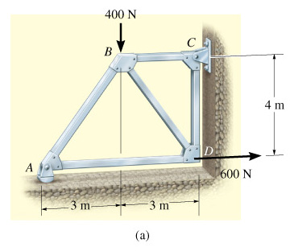

Graphics and problem statements © 2004 R.C. Hibbeler.
Published by Pearson Education, Inc., Upper Saddle River, NJ.
Figure 1

Drawing free-body diagrams of each joint in turn from A through D, always assuming that every member is in tension and that the unknown reactions are in the positive directions, summing the forces in the horizontal and vertical directions gives the following equations:

Joint A: ∑F_{x} = F_{AD} + (3/5)F_{AB} = 0
∑F_{y} = A_{y} + (4/5)F_{AB} = 0

Joint B: ∑F_{x} = F_{BC} + (3/5)F_{BD} - (3/5)F_{AB} = 0
∑F_{y} = -400 N - (4/5)F_{AB} - (4/5)F_{BD} = 0

Joint C: ∑F_{x} = -F_{BC} + C_{x} = 0
∑F_{y} = C_{y} - F_{CD} = 0

Joint D: ∑F_{x} = -F_{AD} - (3/5)F_{BD} + 600 N = 0
∑F_{y} = F_{CD} + (4/5)F_{BD} = 0

(Verify these equations) These are 8 equations (2 times the number of joints) for 8 unknowns (5 unknown member forces and three unknown support reactions).

If we assume that the members are all in tension, then the coefficients of the equations above can be seen by inspection of Figure 1 above. Consider joint B. The coefficient of F_{BD} at joint B in the x-direction is the signed horizontal distance from B to D divided by the distance from B to D: 3/5. The coefficient of F_{BD} at joint B in the y-direction is the signed vertical distance from B to D divided by the distance from B to D: -4/5. At joint D, the coefficient of F_{AD} in the x-direction is the signed horizontal distance from D to A divided by the distance from D to A: -1; the coefficient of F_{AD} in the y-direction is the signed vertical distance from D to A divided by the distance from D to A: 0. The coefficients of the unknown reaction forces are always 1 if we assume that they are in the positive coordinate directions. With this convention, members that result in negative members forces are in compression; negative reaction forces are in the negative coordinate directions.

The coefficients of the member forces in the equilibrium equations are the direction cosines of the vectors that point along the members of the truss. For example, the unit vector from B to D in the truss above is λ_{BD} = r_{BD}/r_{BD} = (3/5)i + (-4/5)j. The components of the member force in BD acting on joint B are the components of this unit vector, and are the direction cosines of the unit vector from B to D.

Instead of the component equations above, write a matrix equation TM + F = 0, where T is the matrix of direction cosines, M are the unknown member and reaction forces and F is the vector of known external forces applied to the truss. It may be helpful to make a table of values to construct the matrix T. The members and reaction forces are the columns of the matrix, the rows represent the joint equations in the x and y directions:

T | F_{AB} | F_{AD} | F_{BC} | F_{BD} | F_{CD} | C_{x} | C_{y} | A_{y}
A_{x} | 3/5 | 1 | 0 | 0 | 0 | 0 | 0 | 0
A_{y} | 4/5 | 0 | 0 | 0 | 0 | 0 | 0 | 1
B_{x} | -3/5 | 0 | 1 | 3/5 | 0 | 0 | 0 | 0
B_{y} | -4/5 | 0 | 0 | -4/5 | 0 | 0 | 0 | 0
C_{x} | 0 | 0 | -1 | 0 | 0 | 1 | 0 | 0
C_{y} | 0 | 0 | 0 | 0 | -1 | 0 | 1 | 0
D_{x} | 0 | -1 | 0 | -3/5 | 0 | 0 | 0 | 0
D_{y} | 0 | 0 | 0 | 4/5 | 1 | 0 | 0 | 0
Table 1

The table above is the matrix T. The vector of unknown member and reaction forces is
M = [ F_{AB} F_{AD} F_{BC} F_{BD} F_{CD} C_{x} C_{y} A_{y} ]

The corresponding vector of known external forces applied to the truss is
F = [ 0 0 0 -400 0 0 600 0 ]^{T}

In terms of a MATLAB program, the solution to this matrix problem is
% Solution is of the form: T*M + F = 0 or T*M=-F
% Fab Fad Fbc Fbd Fcd Cx Cy Ay
T=[ 0.6 1 0 0 0 0 0 0; % Ax
0.8 0 0 0 0 0 0 1; % Ay
-0.6 0 1 0.6 0 0 0 0; % Bx
-0.8 0 0 -0.8 0 0 0 0; % By
0 0 -1 0 0 1 0 0; % Cx
0 0 0 0 -1 0 1 0; % Cy
0 -1 0 -0.6 0 0 0 0; % Dx
0 0 0 0.8 1 0 0 0] % Dy
F=[0; 0; 0; -400; 0; 0; 600; 0] % Applied forces, as shown on the truss
M=inv(T)*(-F)

(Why is F multiplied by -1?) Resulting in:
T =

0.6000 1.0000 0 0 0 0 0 0
0.8000 0 0 0 0 0 0 1.0000
-0.6000 0 1.0000 0.6000 0 0 0 0
-0.8000 0 0 -0.8000 0 0 0 0
0 0 -1.0000 0 0 1.0000 0 0
0 0 0 0 -1.0000 0 1.0000 0
0 -1.0000 0 -0.6000 0 0 0 0
0 0 0 0.8000 1.0000 0 0 0

F =

0
0
0
-400
0
0
600
0

M =

-750.0000
450.0000
-600.0000
250.0000
-200.0000
-600.0000
-200.0000
600.0000

>>

The resulting values of M are the previously unknown member and reaction forces.

Laboratory Exercises:

Apply this method to the following truss problems:
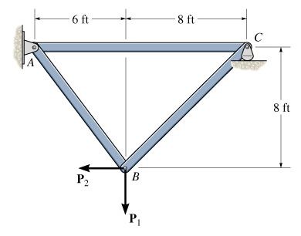 | 1. Determine the force in each member of the truss and state if the members are in tension or compression. Let P₁ = 800 lb and P₂ = 400 lb.  Ans:  F_{AB} = 286 lb (T)  F_{BC} = 808 lb (T)  F_{AC} = 571 lb (C)
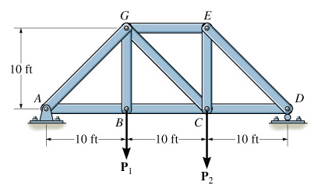 | 2. Determine the force in each member of the truss and state if the members are in tension or compression. Let P₁ = 500 lb and P₂ = 1500 lb.  Ans:  F_{AG} = 1179 lb (C), F_{AB} = 833 lb (T),  F_{BC} = 833 lb (T), F_{BG} = 500 lb (T),  F_{DE} = 1650 lb (C), F_{EG} = 1167 lb (C),  F_{CG} = 471 lb (T)
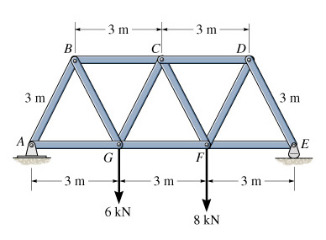 | 3. Determine the force in each member of the Warren truss and state if the members are in tension or compression.  Partial Ans:  F_{FG} = 8.08 kN (T)  F_{CD} = 8.47 kN (C)  F_{CF} = 0.770 kN (T)
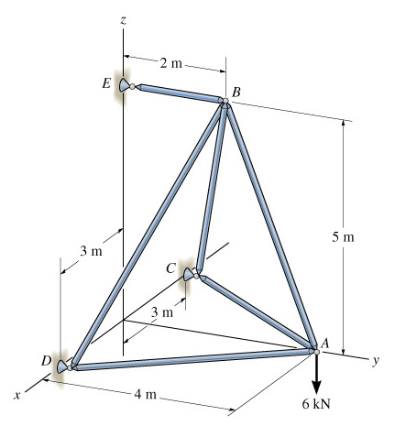 | EXTRA CREDIT:  The method described here can also be applied to three-dimensional trusses. In this case, there will be three rows in T for each joint.  EC 1. Determine the force in each member of the three-dimensional truss and state if the members are in tension or compression.  F_{AB} = 6.46 kN (T)  F_{AC} = F_{AD} = 1.5 kN (C)  F_{BC} = F_{BD} = 3.7 kN (C)  F_{BE} = 4.8 kN (T)

