EGR 280 – Mechanics Problem Set 9
Graphics and problem statements © 2004 R.C. Hibbeler.
Published by Pearson Education, Inc., Upper Saddle River, NJ.

9.1 A garden hose discharges water at the rate of 15 m/s. If the nozzle is held at ground level and directed θ = 30° from the ground, determine the maximum height reached by the water and the horizontal distance from the nozzle to where the water strikes the ground.

Ans: h = 2.87 m, s_{x} = 19.9 m

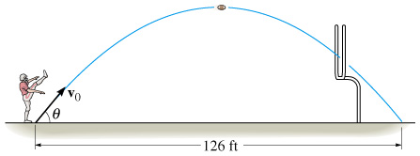 | 9.2 From a videotape, it was observed that a pro football player kicked a football 126 ft during a measured time of 3.6 seconds. Determine the initial speed of the ball and the angle θ at which it was kicked.  Ans: v₀ = 67.7 ft/s, θ = 58.9°
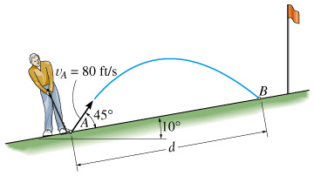 | 9.3 A golf ball is struck with a velocity of 80 ft/s as shown. Determine the distance d to where it will land.  Ans: d = 166 ft
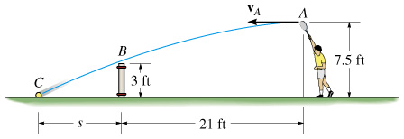 | 9.4 Determine the horizontal velocity v_{a} of a tennis ball at A so that it just clears the net at B. Also, find the distance s where the ball strikes the ground.  Ans: v_{A} = 39.7 ft/s, s = 6.11 ft
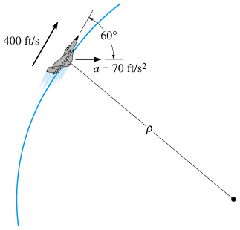 | 9.5 At a given instant, the jet plane as a speed of 400 ft/s and an acceleration of 70 ft/s2 acting in the direction shown. Determine the rate of increase in the plane’s speed and the radius of curvature ρ of the path.  Ans: a_{t} = 35.0 ft/s², ρ = 2640 ft
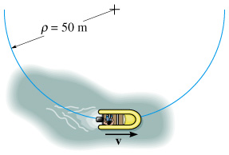 | 9.6 Starting from rest, the motorboat travels around a circular path, ρ = 50 m, at a speed of v = (0.8t)m/s, where t is in seconds. Determine the magnitudes of the boat’s velocity and acceleration when it has traveled 20 m.  Ans: v = 5.66 m/s, a = 1.02 m/s²
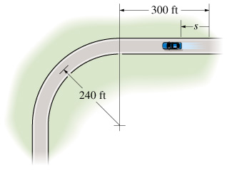 | 9.7 The automobile is originally at rest at s = 0. If its speed is increased by dv/dt = (0.05t²)ft/s², where t is in seconds, determine magnitudes of its velocity and acceleration when t = 18 s.  Ans: v = 97.2 ft/s, a = 42.6 ft/s²
9.8 For the car of Problem 8.7, determine the magnitudes of its velocity and acceleration at s = 550 ft.

Ans: v = 115 ft/s, a = 58.4 ft/s²

9.9 The motion of a particle is defined by the equations x = (2t + t²)m and y = t²m, where t is in seconds. Determine the normal and tangential components of the particle’s velocity and acceleration when t = 2s

Ans: v_{n} = 0, v_{t} = 7.21 m/s, a_{n} = 0.555 m/s², a_{t} = 2.77 m/s²

