EGR 280 – Mechanics Problem Set 8
Graphics and problem statements © 2004 R.C. Hibbeler.
Published by Pearson Education, Inc., Upper Saddle River, NJ.

8.1 A bicyclist starts from rest and after traveling along a straight path a distance of 20 m reaches a speed of 30 km/h. Determine her constant acceleration. How long does it take her to reach 30 km/hr?

Ans: a = 1.74 m/s², t = 4.80 s

8.2 A car starts from rest and reaches a speed of 80 ft/s after traveling 500 ft along a straight road. Determine the constant acceleration and the time of travel.

Ans: a = 6.40 ft/s², t = 12.5 s

8.3 Traveling with an initial speed of 70 km/hr, a car accelerates at 6000 km/hr² along a straight road. How long will it take to reach a speed of 120 km/h? Through what distance does the car travel during this time?

Ans: t = 30 s, s = 792 m

8.4 The position of a particle along a straight line is given as s = (t³ – 9t² + 15t)ft, where t is in seconds. Determine its maximum acceleration and maximum velocity during the time interval 0 ≤ t ≤ 10 s

Ans: a_{max} = 42 ft/s², v_{max} = 135 ft/s

8.5 A particle travels in a straight line such that for a short time 2 s ≤ t ≤ 6 s it motion is described by v = (4/a)ft/s, where a is in ft/s². If v = 6 ft/s when t = 2 s, determine the particle’s acceleration when t = 3 s.

Ans: a = 0.603 ft/s²

8.6 The acceleration of a particle as it moves along a straight line is given by
a = (2t-1)m/s², where t is in seconds. If s = 1m and v = 2 m/s when t = 0, determine the particle’s velocity and position when t = 6 s. Also, determine the total distance the particle travels during this time period.

Ans: v = 32 m/s, s = 67 m, d = 66 m

8.7 Two particles A and B start from rest at the origin s = 0 and move along a straight line such that a_{A} = (6t-3)ft/s² and a_{B} = (12t²-8)ft/s², where t is in seconds. Determine the distance between them when t = 4 s and the total distance each has traveled in t = 4 s.

Ans: d_{A} = 41.0 ft, d_{B} = 200 ft, ∆s_{AB} = 152 ft

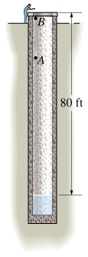 | 8.8 A stone A is dropped from rest down a well, and in 1 s another stone B is dropped from rest. Determine the distance between the stones another second later.  Ans: ∆s = 48.3 ft
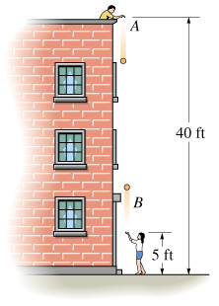 | 8.9 Ball A is released from rest at a height of 40 ft at the same time that a second ball B is thrown upward 5 ft from the ground. If the balls pass one another at a height of 20 ft, determine the speed at which ball B was thrown upward.  Ans: v_{B} = 31.4 ft/s

