EGR 280 – Mechanics Problem Set 7
Graphics and problem statements © 2004 R.C. Hibbeler.
Published by Pearson Education, Inc., Upper Saddle River, NJ.

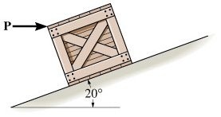 | 7.1 If the horizontal force P = 80 lb, determine the normal and frictional forces acting on the 300-lb crate. Take μ_{s}= 0.3 and μ_{k}= 0.2.  Ans: F_{c} = 27.4 lb, N_{c} = 309 lb
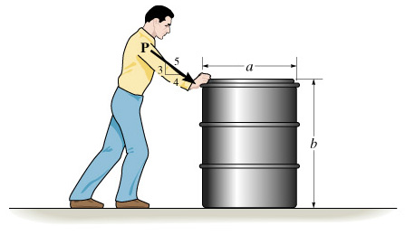 | 7.2 The drum weighs 100 lb and rests on the floor for which the coefficient of static friction is μ_{s}= 0.5. If a = 3 ft and b = 4 ft, determine the smallest magnitude of P to cause impending motion of the drum  Ans: P = 100 lb
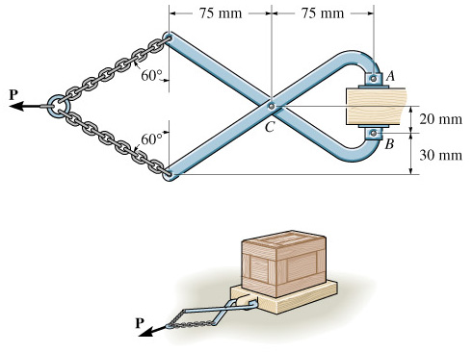 | 7.3 The coefficient of friction between the shoes at A and B of the tongs and the pallet is μ’_{s}= 0.5, and between the pallet and the floor is μ_{s}= 0.4. If a horizontal towing force P = 300 N is applied to the tongs, determine the largest mass that can be towed.  Ans: m = 54.9 kg
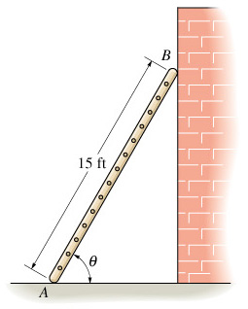 | 7.4 The 15-ft ladder has a uniform weight of 80 lb and rests against the smooth wall at B. If the coefficient of static friction at A is μ_{s}= 0.4, determine if the ladder will slip. Take θ = 60°  Ans: the ladder will not slip.
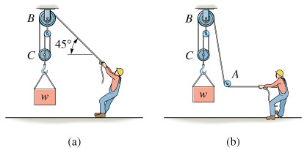 | 7.5 Determine the maximum weight W the man can lift with constant velocity using the pulley system, without and then with the “leading block”, or pulley at A. The man weighs 200 lb and the coefficient of friction between his feet and the ground is μ_{s}= 0.6.  Ans:  (a) W = 318 lb,  (b) W = 360 lb
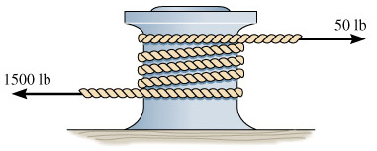 | 7.6 A “hawser” is wrapped around a fixed “capstan” to secure a ship for docking. If the tension in the rope caused by the ship is 1500 lb, determine the minimum number of turns the rope must be wrapped around the capstan to prevent slipping, assuming that the end of the rope is held with a force of 50 lb. μ_{s}= 0.3.  Ans: 2 turns
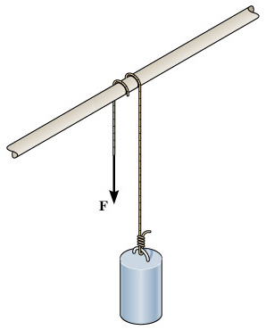 | 7.7 A cylinder having a mass of 250 kg is to be supported by the cord which wraps over the pipe shown. Determine the largest vertical force F that can be applied to the cord without moving the cylinder if the rope passes over the pipe (a) once or (b) twice. Let μ_{s}= 0.2.  Ans:  - F = 4.60 kN  - F = 16.2 kN
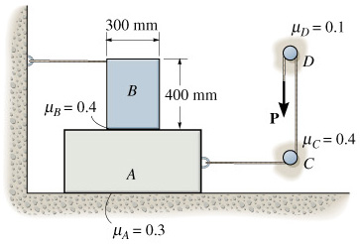 | 7.8 Blocks A and B have mass of 7 kg and 10 kg, respectively. Using the coefficients of static friction shown, determine the largest vertical force P which can be applied to the cord without causing motion.  Ans: P = 223 N

