EGR 280 – Mechanics Problem Set 6
Graphics and problem statements © 2004 R.C. Hibbeler.
Published by Pearson Education, Inc., Upper Saddle River, NJ.

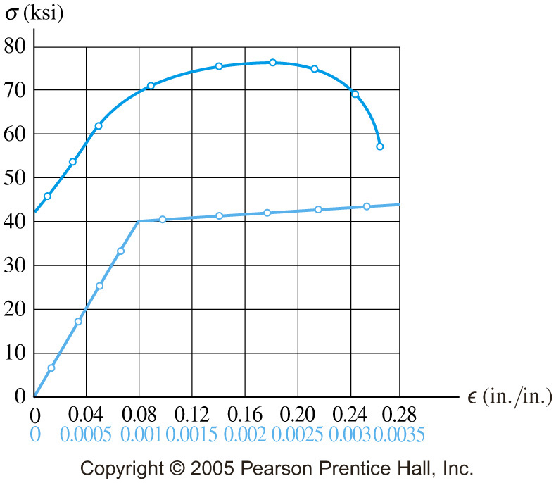 | 6.1 The stress–strain diagram for a steel alloy having an original diameter of 0.5 in. and a gauge length of 2 in. is given in the figure. Determine approximately the modulus of elasticity for the material, the load on the specimen that causes yielding, and the ultimate load the specimen will support.  Ans:  E = 40x10³ ksi  P_{y} = 7.85 kip  P_{u} = 15.0 kip
6.2 A 60-m long steel wire must not stretch more than 48 mm when the tension in the wire is 6 kN. Knowing that E = 200 GPa, determine (a) the smallest diameter which may be selected for the wire, (b) the corresponding value of the normal stress
Ans:
- 6.91 mm
- 160.0 MPa
6.3 A nylon thread is subjected to a 2-lb tension. Knowing that E = 0.5 Mpsi and that the maximum allowable normal stress is 6 ksi, determine (a) the required diameter of the thread, (b) the corresponding percent increase in length of the thread.
Ans:
- 0.0206 in
- 1.20%
6.4 A 4-mm diameter aluminum wire is observed to stretch 25 mm when the tension in the wire is 400 N. Knowing that E = 70 GPa, determine (a) the length of the wire, (b) the stress in the wire.
Ans:
- 55.0 m
- 31.8 MPa

