EGR 280 – Mechanics Problem Set 5
Graphics and problem statements © 2004 R.C. Hibbeler.
Published by Pearson Education, Inc., Upper Saddle River, NJ.

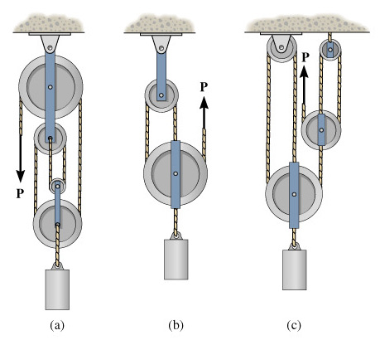 | 5.1 In each case, determine the force P required to maintain equilibrium. The block weighs 100 lb.  Ans:  - P = 25.0 lb  - P = 33.3 lb  - P = 11.1 lb
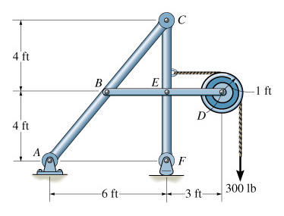 | 5.2 Determine the horizontal and vertical components of force at C which member ABC exerts on member CEF.  Ans:  C_{x} = 75 lb  C_{y} = 100 lb
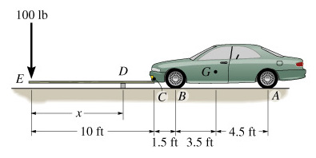 | 5.3 The front of the car is to be lifted using a rigid 10-ft long board. The car weighs 3,500 lb with center of gravity at G. Determine the position x of the fulcrum so that an applied force of 100 lb at E will lift the front of the car.  Ans: x = 9.43 ft
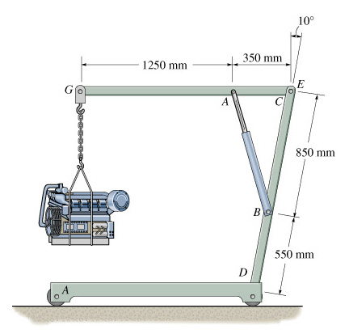 | 5.4 The engine hoist is used to support the 200-kg engine. Determine the force acting in the hydraulic cylinder AB, the horizontal and vertical components of force at the pin C and the reactions at the fixed support D.  Ans:  F_{AB} = 9.23 kN  C_{x} = 2.17 kN  C_{y} = 7.01 kN  D_{x} = 0  D_{y} = 1.96 kN  M_{D} = 2.66 kN-m
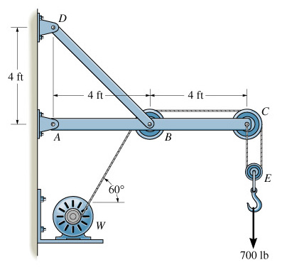 | 5.5 The wall crane supports a load of 700 lb. Determine the horizontal and vertical components of reaction at the pins A and D. Also, what is the force in the cable at the winch W?  Ans:  T = 350 lb  A_{y} = 700 lb  A_{x} = 1.88 kip  D_{x} = 1.70 kip  D_{y} = 1.70 kip
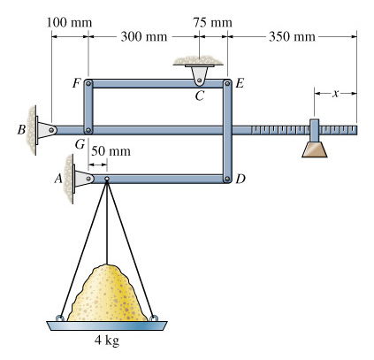 | 5.6 The compound arrangement of the pan scale is shown. If the mass on the pan is 4 kg, determine the horizontal and vertical components of force at pins A, B and C and the distance x of the 25-g mass to keep the scale in balance.  Ans:  A_{y} = 34.0 N, A_{x} = 0  C_{y} = 6.54 N, C_{x} = 0  B_{y} = 1.06 N, B_{x} = 0  x = 292 mm,

