EGR 280 – Mechanics Problem Set 4
Graphics and problem statements © 2004 R.C. Hibbeler.
Published by Pearson Education, Inc., Upper Saddle River, NJ.

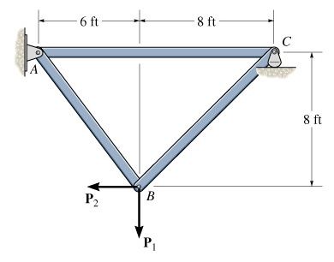 | 4.1 Determine the force in each member of the truss and state if the members are in tension or compression. Let P₁ = 800 lb and P₂ = 400 lb.  Ans:  F_{AB} = 286 lb (T), F_{BC} = 808 lb (T),  F_{AC} = 571 lb (C)
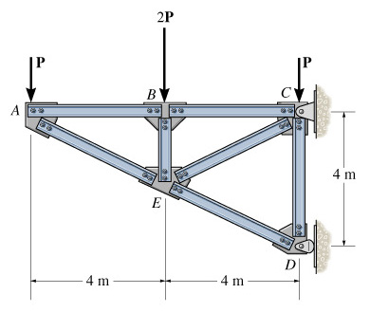 | 4.2 Determine the force in each member of the truss and state if the members are in tension or compression. Assume each joint as a pin.  Let P = 4 kN  Ans:  F_{AE} = 8.94 kN (C), F_{AB} = 8.00 kN (T),  F_{BC} = 8.00 kN (T), F_{BE} = 8.00 kN (C),  F_{CE} = 8.94 kN (T), F_{DE} = 17.9 kN (C)
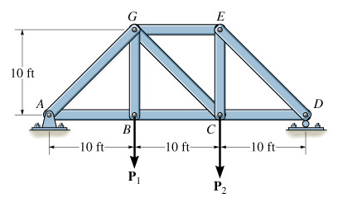 | 4.3 Determine the force in each member of the truss and state if the members are in tension or compression. Let P₁ = 500 lb and P₂ = 1500 lb.  Ans:  F_{AG} = 1179 lb (C), F_{AB} = 833 lb (T),  F_{BC} = 833 lb (T), F_{BG} = 500 lb (T),  F_{DE} = 1650 lb (C), F_{EG} = 1167 lb (C),  F_{CG} = 471 lb (T)
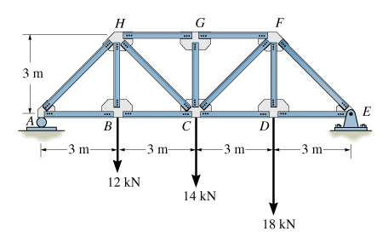 | 4.4 Determine the force in members BC, CH and GH of the bridge truss, and indicate whether the members are in tension or compression.  Ans:  F_{GH} = 29.0 kN (C), F_{BC} = 20.5 kN (T),  F_{CH} = 12.0 kN (T)
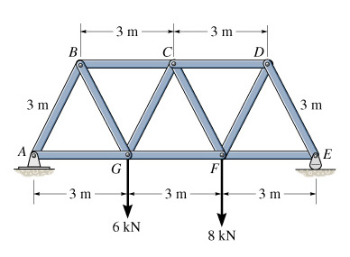 | 4.5 Determine the force in members CD, CF and FG of the Warren truss, and indicate whether the members are in tension or compression.  Ans:  F_{FG} = 8.08 kN (T), F_{CD} = 8.47 kN (C),  F_{CF} = 0.770 kN (T)

