EGR 280 – Mechanics Problem Set 3
Graphics and problem statements © 2004 R.C. Hibbeler.
Published by Pearson Education, Inc., Upper Saddle River, NJ.

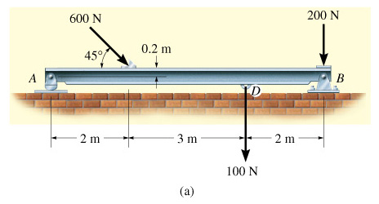 | 3.1 Determine the horizontal and vertical components of reaction for the beam loaded as shown. Neglect the weight of the beam.  Ans:  A_{y} = 319 N, B_{x} = 424 N, B_{y} = 405 N
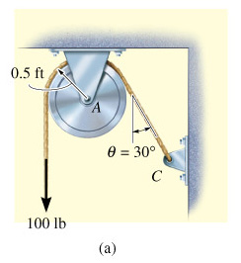 | 3.2 The cord shown supports a force of 100 lb and wraps over a frictionless pulley. Determine the tension in the cord at C and the horizontal and vertical components of the reaction at pin A.  Ans:  T = 100 lb, A_{x} = 50.0 lb, A_{y} = 187 lb
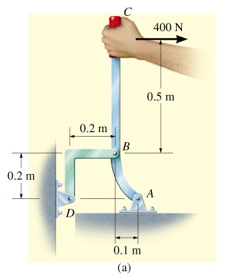 | 3.3 The lever ABC is pin-supported at A and connected to a short link BD as shown. If the weight of the members is negligible, determine the components of the force of the pin on the lever at A.  Ans: A_{x} = 533 N, A_{y} = 933 N
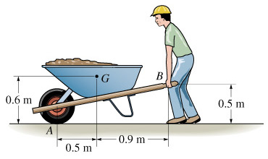 | 3.4 If the wheelbarrow and its contents have a mass of 60 kg and a center of mass at G, determine the magnitude of the resultant force which the man must exert on each of the two handles in order to hold the wheelbarrow in equilibrium.  Ans: F_{B} = 105 N
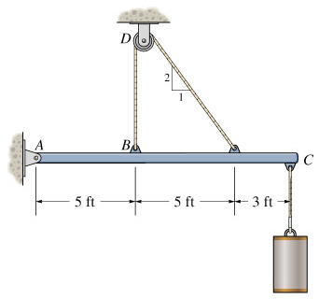 | 3.5 Determine the tension in the cable and the horizontal and vertical components of the reaction at pin A. The pulley at D is frictionless and the cylinder weighs 80 lb.  Ans:  T = 74.6 lb  A_{x} = 33.4 lb  A_{y} = 61.3 lb
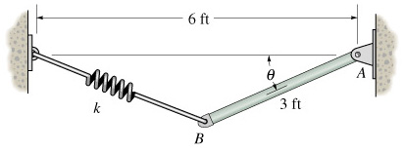 | 3.6 The uniform rod AB has a weight of 15 lb and the spring is unstretched when θ = 0°. If θ = 30°, determine the stiffness k of the spring so that the rod is in equilibrium.  Ans: k = 11.2 lb/ft
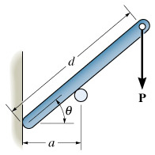 | 3.7 Determine the distance d for placement of the load P for equilibrium of the smooth bar in the position θ as shown. Neglect the weight of the bar.  Ans: d = a/cos³θ
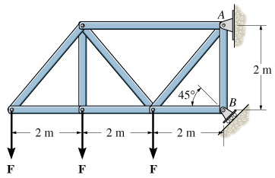 | 3.8 If the roller at B can sustain a maximum load of 3 kN, determine the largest magnitude of each of the three forces F that can be supported by the truss.  Ans: F = 354 N

