EGR 280 – Mechanics Problem Set 18
Graphics and problem statements © 2004 R.C. Hibbeler.
Published by Pearson Education, Inc., Upper Saddle River, NJ.

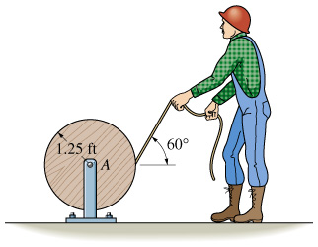 | 18.1 The man pulls the rope off the reel with a constant force of 8 lb in the direction shown. If the reel has a weight of 250 lb and a radius of gyration k_{A} = 0.8 ft, determine the angular velocity of the reel in 3 s starting from rest. Neglect friction and the weight of rope removed.  Ans: ω = 6.04 rad/s
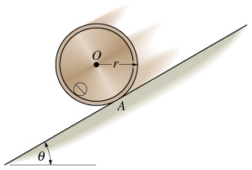 | 18.2 The drum has a mass of 70 kg, a radius of 300 mm and radius of gyration k_{O} = 125 mm. If μ_{s}= 0.4 and μ_{k} = 0.3, determine the drum’s angular velocity 2 s after it is released from rest. Take θ = 30°.  Ans: ω = 27.9 rad/s
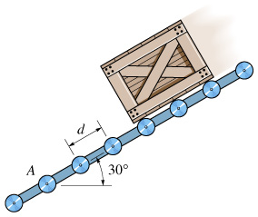 | 18.3 The crate has a mass m_{c}. Determine the constant speed v_{o} it acquires as it moves down the conveyor. Treat the rollers as thin rings with have mass m, radius r and spaced d apart. Note that friction causes each roller to rotate when the crate comes in contact with it.  Ans: v₀² = (2gdm_{c}/m) sinθ
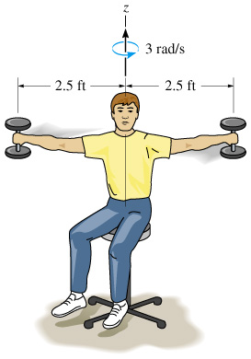 | 18.4 The man sits on the swivel chair holding two 5-lb weights with his arms outstretched. If he is turning at 3 rad/s in this position, determine his angular velocity when the weights are drawn in and held 0.3 ft from the axis of rotation. Assume he weighs 160 lb and has a radius of gyration of k_{z}=0.55 ft about the z-axis. Neglect the mass of his arms and the size of the weights.  Ans: ω = 6.75 rad/s
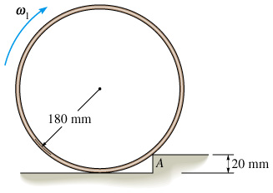 | 18.5 A thin ring having a mass of 15 kg strikes the 20-mm high step. Determine the minimum angular velocity ω₁ the ring can have so that it will just roll over the step at A when it strikes it.  Ans: ω₁ = 2.606 rad/s
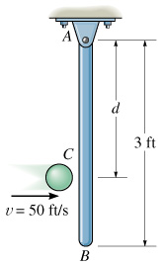 | 18.6 The 6-lb slender rod AB is originally at rest, suspended in the vertical position. A 1-lb ball is thrown at the rod with a velocity v = 50 ft/s and strikes the rod at C. Determine the angular velocity of the rod just after the impact. Let e = 0.7 and d = 2 ft.  Ans: ω₂ = 5.23 rad/s

