EGR 280 – Mechanics Problem Set 16
Graphics and problem statements © 2004 R.C. Hibbeler.
Published by Pearson Education, Inc., Upper Saddle River, NJ.

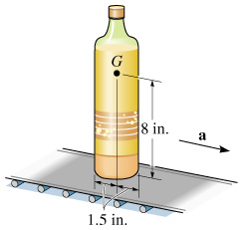 | 16.1 The 2-lb bottle rests on the check-out conveyor at a grocery store. If the coefficient of static friction is μ_{s} = 0.2, determine the largest acceleration the conveyor can have without causing the bottle to slip or tip. The center of gravity is at G.  Ans: a_{G} = 6.04 ft/s²
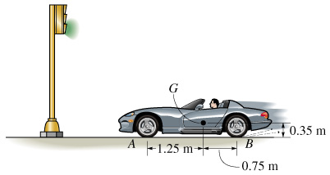 | 16.2 The sports car has a mass of 1.5 Mg and a center of gravity at G. Determine the shortest time it takes for it to reach a speed of 80 km/hr, starting from rest, if the engine drives only the rear wheels. μ_{s} = 0.2. Neglect the mass of the wheels. If power can be supplied to all wheels, what would be the shortest time for the car to reach 80 km/hr?  Ans: rear wheels: t = 17.5 s  4 wheels: t = 11.3 s.
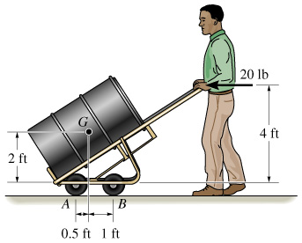 | 16.3 The drum truck supports the 600-lb drum that has a center of gravity at G. If the operator pushes it forward with a horizontal force of 20 lb, determine the acceleration of the truck and the normal reactions at each of the four wheels. Neglect the mass of the wheels.  Ans: a_{G} = 1.07 ft/s², N_{B} = 86.7 lb,  N_{A} = 213 lb
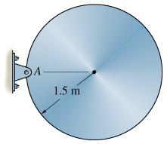 | 16.4 The 80-kg disk is supported by a pin at A. If it is released from rest from the position shown, determine the initial horizontal and vertical reactions at the pin.  Ans: A_{x} = 0, A_{y} = 262 N
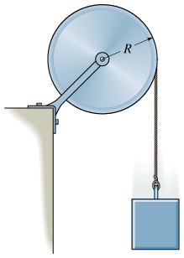 | 16.5 The disk has a mass M and a radius R. If a block of mass m is attached to the cord, determine the angular acceleration of the disk when the block is released from rest. Also, what is the velocity of the block after it falls a distance of 2R starting from rest?  Ans: α = 2mg/[R(M + 2m)]  v² = 8mgR/(M + 2m)
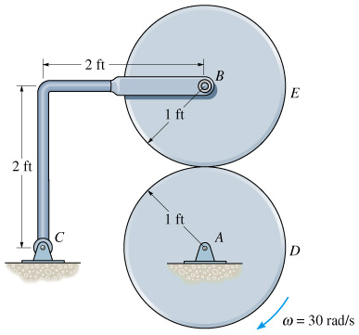 | 16.6 Disk D turns with a constant clockwise angular velocity of 30 rad/s. Disk E has a weight of 60 lb and is initially at rest when it is brought into contact with D. If μ_{k} = 0.3, determine the time required for disk E to attain the same angular velocity as disk D. Neglect the weight of bar BC.  Ans: t = 1.09 s
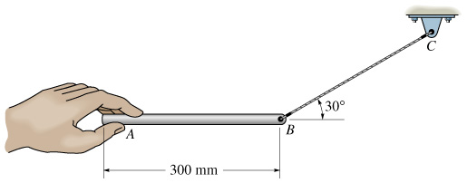 | 16.7 The 2-kg slender bar is supported by cord BC and then released from rest at A. Determine the initial angular acceleration of the bar and the tension in the cord.  Ans: α = 28.0 rad/s², T = 5.61 N
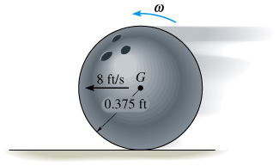 | 16.8 The 16-lb bowling ball is cast horizontally onto a lane such that initially ω=0 and its mass center has a velocity v = 8 ft/s. If μ_{k} = 0.12, determine the distance the ball travels before it rolls without slipping. Neglect the finger holes and assume the ball has a uniform density.  Ans: s = 4.06 ft
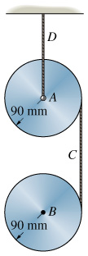 | 16.9 A cord C is wrapped around each of the two 10-kg disks. If they are released from rest, determine the tension in the fixed cord D. Neglect the mass of the cord.  Ans: A_{y} = 118 N

