EGR 280 – Mechanics Problem Set 15
Graphics and problem statements © 2004 R.C. Hibbeler.
Published by Pearson Education, Inc., Upper Saddle River, NJ.

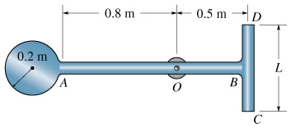 | 15.1 The assembly consists of a disk having a mass of 6 kg and slender rods AB and DC which have a mass of 2 kg/m. If L = 0.75 m, determine the moment of inertia about an axis perpendicular to the page and passing through O.  Ans: I_{O} = 6.99 kg-m²
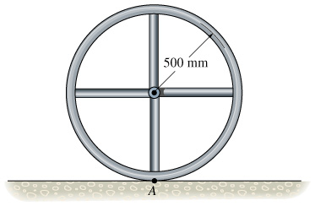 | 15.2 The wheel consists of a thin ring having a mass of 10 kg and four spokes made from slender rods and each having a mass of 2 kg. Determine the wheel’s moment of inertia about an axis perpendicular to the page and passing through point A.  Ans: I_{A} = 7.67 kg-m²
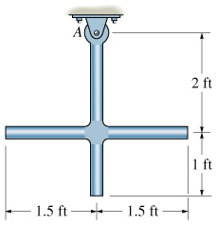 | 15.3 The slender rods have a weight of 3 lb/ft. Determine the moment of inertia of the assembly about an axis perpendicular to the page and passing through the pin at A.  Ans: I_{A} = 2.17 (lb-s²/ft) -ft²
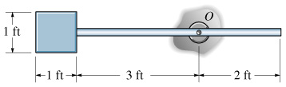 | 15.4 The pendulum consists of a plate having a weight of 12 lb and a slender rod having a weight of 4 lb. Determine the radius of gyration of the pendulum about an axis perpendicular to the page and passing through point O.  Ans: k_{O} = 3.15 ft
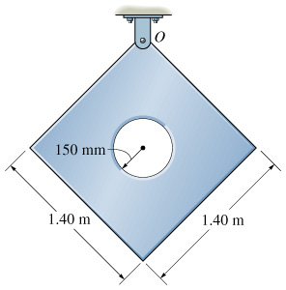 | 15.5 Determine the moment of inertia about an axis perpendicular to the plate and passing through the pin at O. The thin plate has a hole in its center. Its thickness is 50 mm, and the material has a density ρ = 50 kg/m³.  Ans: I_{O} = 6.23 kg-m²

