EGR 280 – Mechanics Problem Set 14
Graphics and problem statements © 2004 R.C. Hibbeler.
Published by Pearson Education, Inc., Upper Saddle River, NJ.

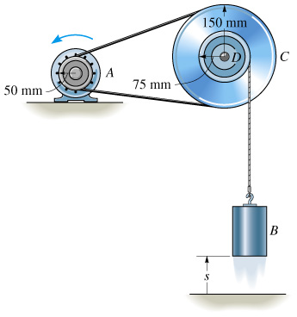 | 14.1 Starting from rest when s = 0, pulley A is given a constant angular acceleration a_{C} = 6 rad/s². Determine the speed of block B when it has risen s = 6 m. The pulley has an inner hub D which is fixed to C and turns with it.  Ans: v_{B} = 1.34 m/s
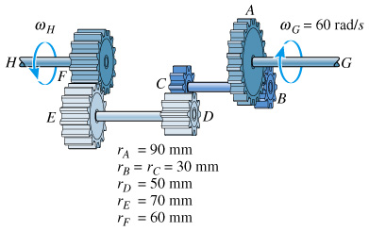 | 14.2 The operation of “reverse” for a 3-speed transmission is illustrated. If the crack shaft G is turning with an angular speed of 60 rad/s, determine the angular speed of the driveshaft H. Each of the gears rotates about a fixed axis. Note that gears A and B, C and D, E and F are in mesh.  Ans: ω_{H} = 126 rad/s
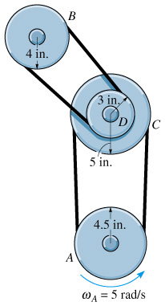 | 14.3 The belt and pulley arrangement shown is used to transmit power. When t = 0, an electric motor is turning pulley A with an angular velocity of ω_{C} = 5 rad/s. If this pulley also has a constant angular acceleration of 2 rad/s², determine the angular velocity of pulley B after B turns 6 revolutions. The hub at D is connected to pulley C and turns with it.  Ans: ω_{B} = 10.6 rad/s
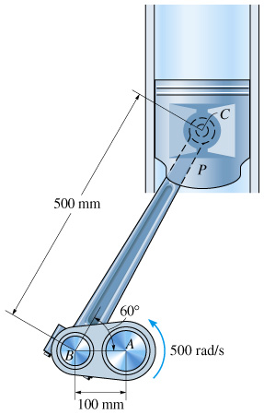 | 14.4 The crankshaft AB is rotating about a fixed axis passing through A. Determine the speed of the piston P at the instant it is the position shown.  Ans: v_{C} = 50 m/s
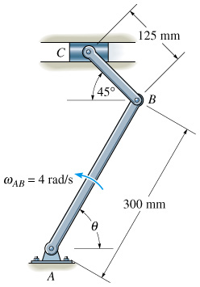 | 14.5 Determine the velocity of the slider block at C at the instant θ = 45°, if link AB is rotating at 4 rad/s.  Ans: v_{C} = 1.70 m/s
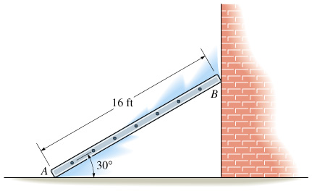 | 14.6 At a given instant the top B of the ladder has an acceleration a_{B} = 2 ft/s² and a velocity of 4 ft/s, both acting downward. Determine the acceleration of bottom A and the ladder’s angular acceleration at this instant.  Ans: α = 0.0962 rad/s²,  a_{A} = 0.385 ft/s² ←
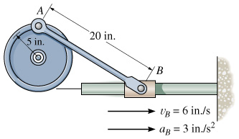 | 14.7 At a given instant the slider block B is traveling to the right with the velocity and acceleration shown. Determine the angular acceleration of the wheel at this instant.  Ans: α_{W} = 0.231 rad/s²

