EGR 280 – Mechanics Problem Set 13
Graphics and problem statements © 2004 R.C. Hibbeler.
Published by Pearson Education, Inc., Upper Saddle River, NJ.

13.1 A 20-lb block slides down a 30° inclined plane with an initial velocity of 2 ft/s. Determine the velocity of the block in 3 s if the coefficient of kinetic friction between the block and the plane is μ_{k} = 0.25.

Ans: v = 29.4 ft/s

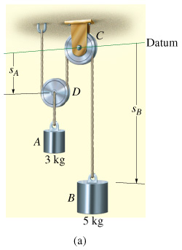 | 13.2 Blocks A and B have mass of 3 kg and 5 kg, respectively. If the system is released from rest, determine the velocity of block B in 6 s. Neglect the mass of the pulleys and cord.  Ans: v_{B} = 35.8 m/s ↓; T = 19.2 N
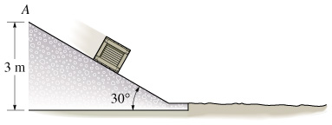 | 13.3 The 5-kg package is released from rest at A. It slides down the smooth plane which is inclined at 30° onto the the rough horizontal surface (μ_{k} = 0.2). Determine the total time of travel before the package stops sliding.  Ans: t = 5.47 s
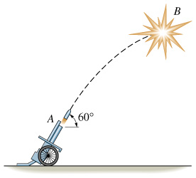 | 13.4 The 10-lb projectile is fired from ground level with an initial velocity of v_{A} = 80 ft/s in the direction shown. When it reaches its highest point B it explodes into two 5-lb fragments. If one fragment travels vertically upward at 12 ft/s, determine the distance between the fragments after they strike the ground.  Ans: R = 145 ft
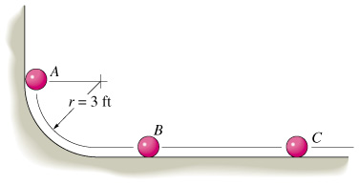 | 13.5 The three balls each weigh 0.5 lb and have a coefficient of restitution of e = 0.85. If ball A is released from rest and strikes ball B, and then ball B strikes ball C, determine the velocity of each ball after the second collision has occurred. The balls slide without friction.  Ans: v_{A2} = 1.04 ft/s, v_{B3} = 0.964 ft/s, v_{C3} = 11.9 ft/s
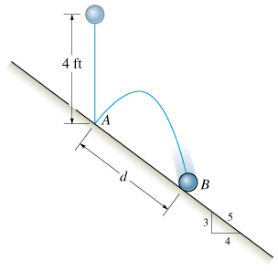 | 13.6 The 1-lb ball is dropped from rest and falls a distance of 4 ft before striking the smooth plane at A. If e = 0.8, determine the distance d to where it again strikes the plane at B.  Ans: d = 13.8 ft
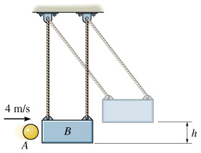 | 13.7 The 2-kg ball is thrown at the suspended 20-kg block with a velocity of 4 m/s. If e = 0.8, determine the maximum height h to which the block will swing before it momentarily stops.  Ans: h = 21.8 mm

