EGR 280 – Mechanics Problem Set 11
Graphics and problem statements © 2004 R.C. Hibbeler.
Published by Pearson Education, Inc., Upper Saddle River, NJ.

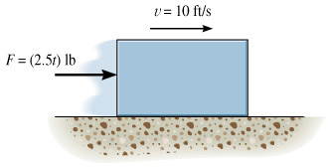 | 11.1 The 10-lb block has an initial velocity of 10 ft/s on the smooth plane. If a force F = (2.5t) lb, where t is in seconds, acts on the block for 3 seconds, determine the final velocity of the block and the distance the block travels during this time.  Ans: v = 46.2 ft/s, s = 66.2 ft
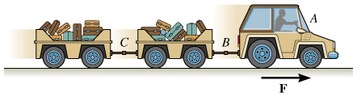 | 11.2 The baggage truck A has a mass of 800 kg and is used to pull two cars, each with a mass of 300 kg. If the tractive force F on the truck is F = 480 N, determine the initial acceleration of the truck. What is the acceleration of the truck if the coupling at C suddenly fails? The car wheels are free to roll; neglect the mass of the wheels.  Ans: a = 0.343 m/s², a = 0.436 m/s²
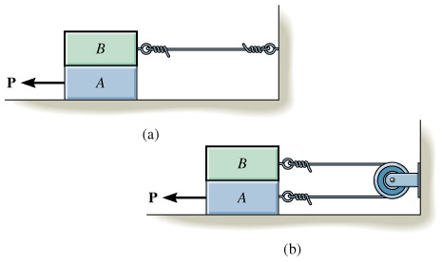 | 11.3 Each of the two blocks has the same mass m. The coefficient of kinetic friction, μ, is the same at all surfaces of contact. If a horizontal force P moves the bottom block, determine the acceleration of the bottom block in each case.  Ans: a_{A} = (P/2m) – 2μg
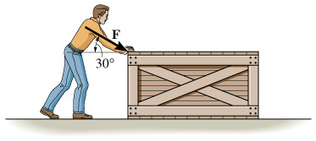 | 11.4 The man pushes on the 60-lb crate with a force F as shown. The magnitude of the force is increased until the crate begins to slide. Determine the crate’s initial acceleration if μ_{s} = 0.6 and μ_{k} = 0.3.  Ans: a = 14.8 ft/s²
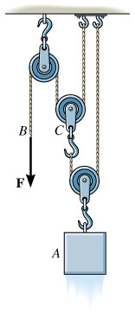 | 11.5 A force F = 15 lb is applied to the cord. Determine how high the 30-lb block A rises in 2 s, starting from rest. Neglect the weight of the cords and the pulleys.  Ans: s = 64.4 ft
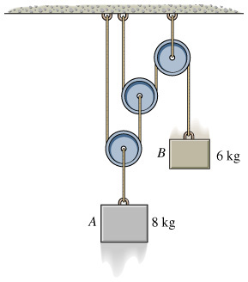 | 11.6 Determine the tension developed in the cords attached to each block and the accelerations of the blocks. Neglect the mass of the pulleys and cords.  Ans:  a_{A} = 1.51 m/s² ↑ , T_{A} = 90.6 N,  a_{B} = 6.04 m/s² ↓ , T_{B} = 22.6 N,
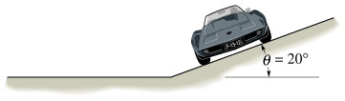 | 11.7 The sports car, having a mass of 1700 kg, is traveling horizontally along a 20° banked circular track with a radius of curvature of 100 m. If μ_{s} = 0.2, determine the maximum constant speed at which the car can travel without sliding up the slope.  Ans: v_{max} = 24.4 m/s
11.8 Using the data in Problem 11.7, determine the minimum constant speed at which the car can travel around the track without sliding down the slope.

Ans: v_{min} = 12.2 m/s

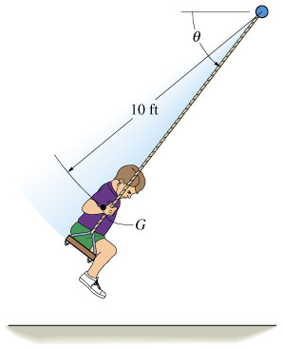 | 11.9 At the instant θ = 60°, the boy’s center of mass G has a downward speed v_{G} = 15 ft/s. Determine the rate of increase in his speed and the tension in each of the two supporting cords of the swing at this instant. The boy weighs 60 lb. Neglect his size and the weight of the seat and the cords.  Ans: a_{t} = 16.1 ft/s², T = 46.9 lb
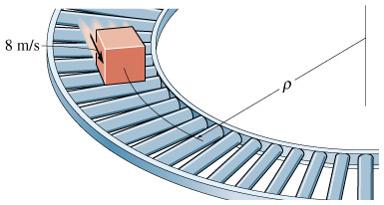 | 11.10 Cartons having a mass of 5 kg are required to move along the assembly line at a constant speed of 8 m/s. Determine the smallest radius of curvature ρ for the conveyor so the cartons do not slip. Assume μ_{s} = 0.7 and μ_{k} = 0.5.  Ans: ρ = 9.32 m

