EGR 280 – Mechanics Problem Set 1
Graphics and problem statements © 2004 R.C. Hibbeler.
Published by Pearson Education, Inc., Upper Saddle River, NJ.

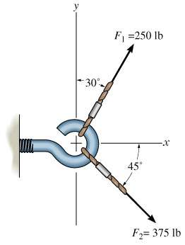 | 1.1 Determine the magnitude of the resultant force and its direction, measured counter-clockwise from the positive x-axis.  Ans: R = 393 lb, θ = 353°
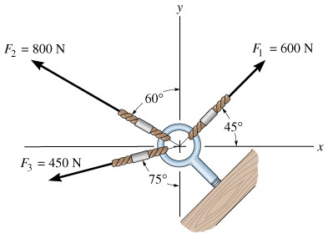 | 1.2 Determine the magnitude of the resultant force and its direction, measured counter-clockwise from the positive x-axis.  Ans: R = 998 N, θ = 135°
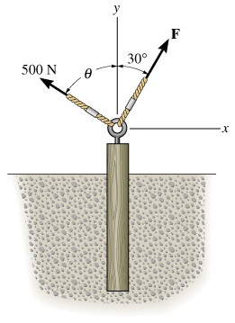 | 1.3 Two forces are applied at the end of a screw eye in order to remove the post. Determine the angle θ (0° ≤ θ ≤ 90°) and the magnitude of the force F so that the resultant force acting on the post is directed vertically upward and has a magnitude of 750 N.  Ans: θ = 18.6°, F = 319 N
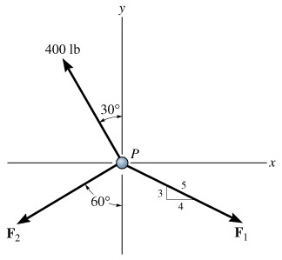 | 1.4 Determine the magnitudes of F₁ and F₂ so that the particle is in equilibrium.  Ans: F₁ = 435 lb, F₂ = 171 lb
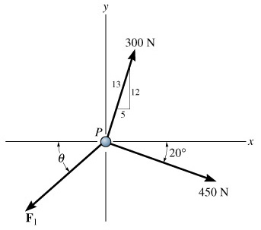 | 1.5 Determine the magnitude and direction of F₁ so that particle P is in equilibrium.  Ans: θ = 12.9°, F₁ = 552 N
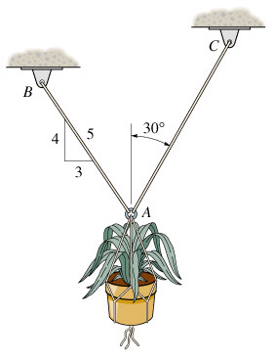 | 1.6 Determine the maximum weight of the flowerpot that can be supported without exceeding a cable tension of 50 lb in either cable AB or AC.  Ans: W = 76.6 lb

